CARDIFF METROPOLITAN UNIVERSITY
School of Technologies · ICBT Campus
CIS6003 — Advanced Programming
WRIT1 — Individual Coursework (100%)
Sunrise Dental Clinic Management System
A pure-Java appointment and billing system: Servlets, JSP and JDBC, with no application framework
Student ID: st[STUDENT-ID]
Academic Year 2025-26 · Semester 1
Word count (excluding references and appendices): approx. 4,000

Table of Contents

Sunrise Dental Clinic Management System
Sunrise Dental Clinic is a private dental practice that currently manages patient appointments and billing on paper. The scenario identifies four consequences of this: double bookings, lost patient records, long waiting times and billing errors. This report documents the analysis, design, implementation, testing and delivery of a computerised replacement, built with no application framework: the entire system — presentation, business logic and data access — is composed by hand from the Jakarta Servlet API, JSP and plain JDBC.
That constraint is deliberate rather than incidental. A framework such as Spring supplies dependency injection, a web MVC layer and an ORM as infrastructure the developer does not write. Building without one means every one of those responsibilities — the composition root that wires objects together, the mapping between a JDBC ResultSet and a domain object, the routing of a request to the code that handles it — is visible in this project's own source, which is what this report evaluates.

Assumptions and design rationale
The scenario leaves several operational details unstated. The brief permits assumptions provided they are explained, so each is recorded below with the reasoning behind it.
# | Assumption | Reasoning
A1 | The clinic operates 09:00–17:00, with appointments booked on the hour. | The scenario mentions long waiting times but gives no schedule. Hourly slots make chair time countable, which is what allows a clash to be detected at all.
A2 | One dentist can hold only one appointment per slot. | This is the direct expression of the double-booking problem and the system's central invariant.
A3 | A returning patient is recognised by name and contact number together. | The clinic has no patient identifier scheme on paper. Matching on both fields reuses an existing record instead of accumulating duplicate files.
A4 | Cancelling releases the slot but retains the record. | A cancelled visit is still clinical history.
A5 | Every visit attracts a consultation fee, plus a treatment charge that varies by treatment. | The brief specifies 'treatment type and consultation fee'. Separating them lets the consultation fee be repriced independently.
A6 | Two roles exist: Receptionist and Manager, the latter additionally seeing revenue reports. | The brief requires authorised access without specifying roles; financial reporting is the one function that plausibly warrants restriction.
A7 | Reprinting a receipt must never create a second billable record. | Not stated in the brief, but the obvious way a real clinic would corrupt its own revenue figures.
A8 | No application framework, container-managed dependency injection or ORM is used anywhere in the system. | The explicit constraint for this submission. Every wiring decision a framework would otherwise make invisibly is instead a class in this project, discussed in the Codebase Evaluation section.
Table 1: Assumptions made, with justification

System Design and Object-Oriented Modeling

Foundational Assumptions and Constraints
The design follows directly from assumption A8: with no framework supplying a dependency-injection container, something in this codebase must play that role, and that something is AppContext — a single class whose constructor wires every DAO and service together by hand and is built exactly once, when the web application starts. Every other design decision below is downstream of keeping that composition root the only place object graphs are assembled, so that the rest of the codebase depends on interfaces and never on how an implementation was constructed.
A second constraint follows from having no ORM: JdbcAppointmentDao and its siblings read and write rows with PreparedStatement and map ResultSet columns to domain objects by hand, including a five-table JOIN to assemble a fully populated Bill. This is more code than an ORM would require, and it is also more honest about what a JOIN actually costs, which the report returns to in the database section.

Use Case Models
The use case diagram establishes the system boundary and the two actors. Manager generalises Receptionist: a manager can perform every reception function and additionally run the revenue report. Two relationship stereotypes are used deliberately: «include» marks behaviour that always occurs as part of the base case — checking dentist availability is not optional — while «extend» marks conditional behaviour, with each extension carrying the condition as a named extension point, such as registering a new patient only when one is not already on file.
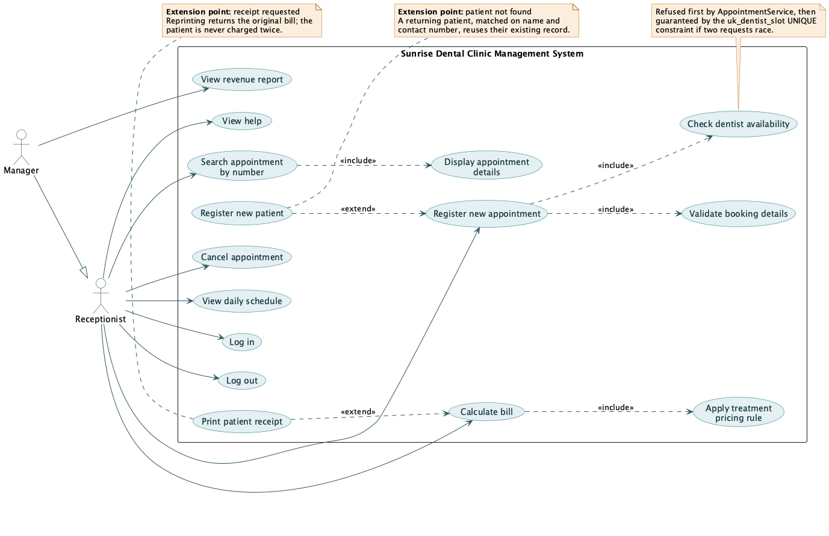
Figure 1: Use case diagram, showing the system boundary, actor generalisation, and «include» / «extend» relationships

Class model
The class model is presented in two diagrams, because a single diagram covering both the domain and the tiers renders too wide to be legible at A4. Splitting it separates two distinct arguments — what the domain is, and how the tiers depend on each other.

Domain model
Attributes are private and reached through public accessors. Three relationship types appear, and the choice between them carries meaning: composition (filled diamond) between Appointment and Bill, since a bill has no meaning apart from the appointment it settles and the 1-to-0..1 multiplicity encodes assumption A7 directly; aggregation (hollow diamond) between Patient and Appointment, since a patient's history is composed of appointments that remain records in their own right; and a directed, one-way association from Appointment to Dentist, TreatmentType and Staff, matching exactly what the code does — an appointment holds a reference to its dentist, the dentist holds none back.
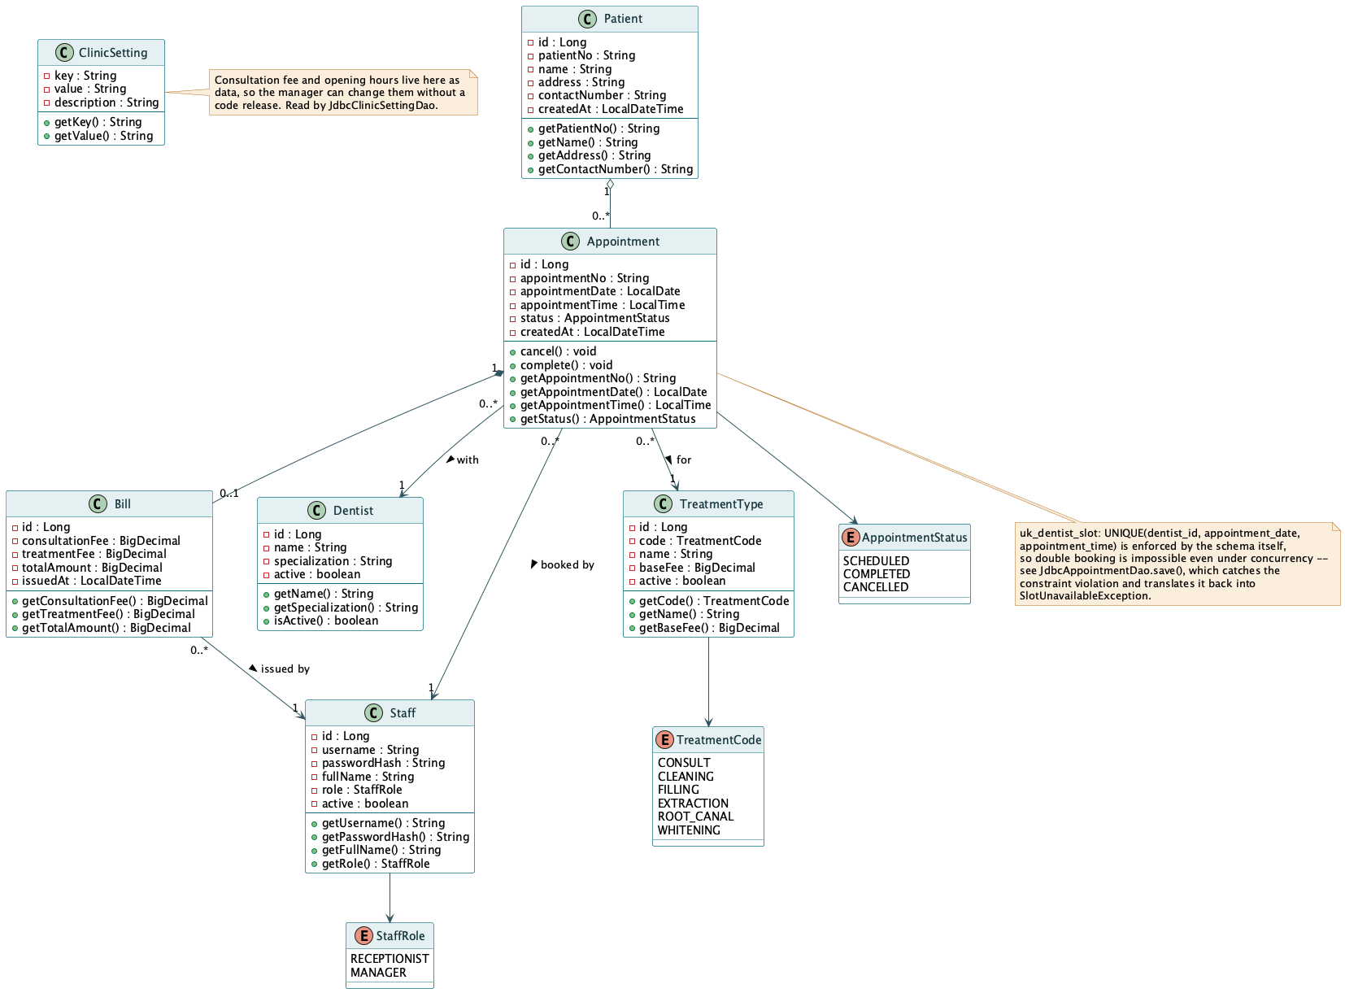
Figure 2: Domain class diagram, with access modifiers, multiplicity, navigability, aggregation and composition

Architectural model
The second class diagram shows the full dependency graph: the servlet tier, the service tier, the billing package implementing Strategy and Factory, the DAO tier, and the util package holding AppContext, AppInitializer, DbConnection and DbConfig — the composition root and its supporting classes. Every arrow points downward. AppointmentApiServlet and AppointmentWebServlet both extend an abstract base (JsonServlet or ViewServlet respectively) which supplies the shared plumbing for reading the request body, writing a response and mapping a thrown exception to an HTTP status, so that concern is written once rather than once per servlet.
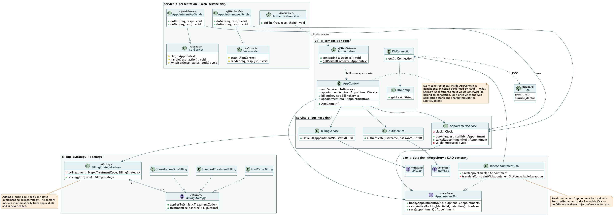
Figure 3: Architectural class diagram — servlet, service, billing, dao and util packages, with realises and depends-on relationships

Sequence model scenarios
Three scenarios were modelled, each exercising a different concern: authentication and session ownership, the central booking transaction under conflict, and the delegation of a pricing decision to a Strategy resolved by a Factory.

Scenario A — Receptionist Books a New Appointment
This is the system's central transaction. The diagram shows AppointmentWebServlet delegating to AppointmentService, which checks availability through AppointmentDao before any row is written, and — in its final fragment — the case in which two receptionists submit the same slot at effectively the same moment. There, the service-layer check has already passed for both requests, and it is the uk_dentist_slot UNIQUE constraint in MySQL, not application code, that rejects the second INSERT. JdbcAppointmentDao.save() catches the resulting SQLIntegrityConstraintViolationException and translates it back into the same SlotUnavailableException the caller already handles, so the caller cannot tell whether the conflict was caught early or late.
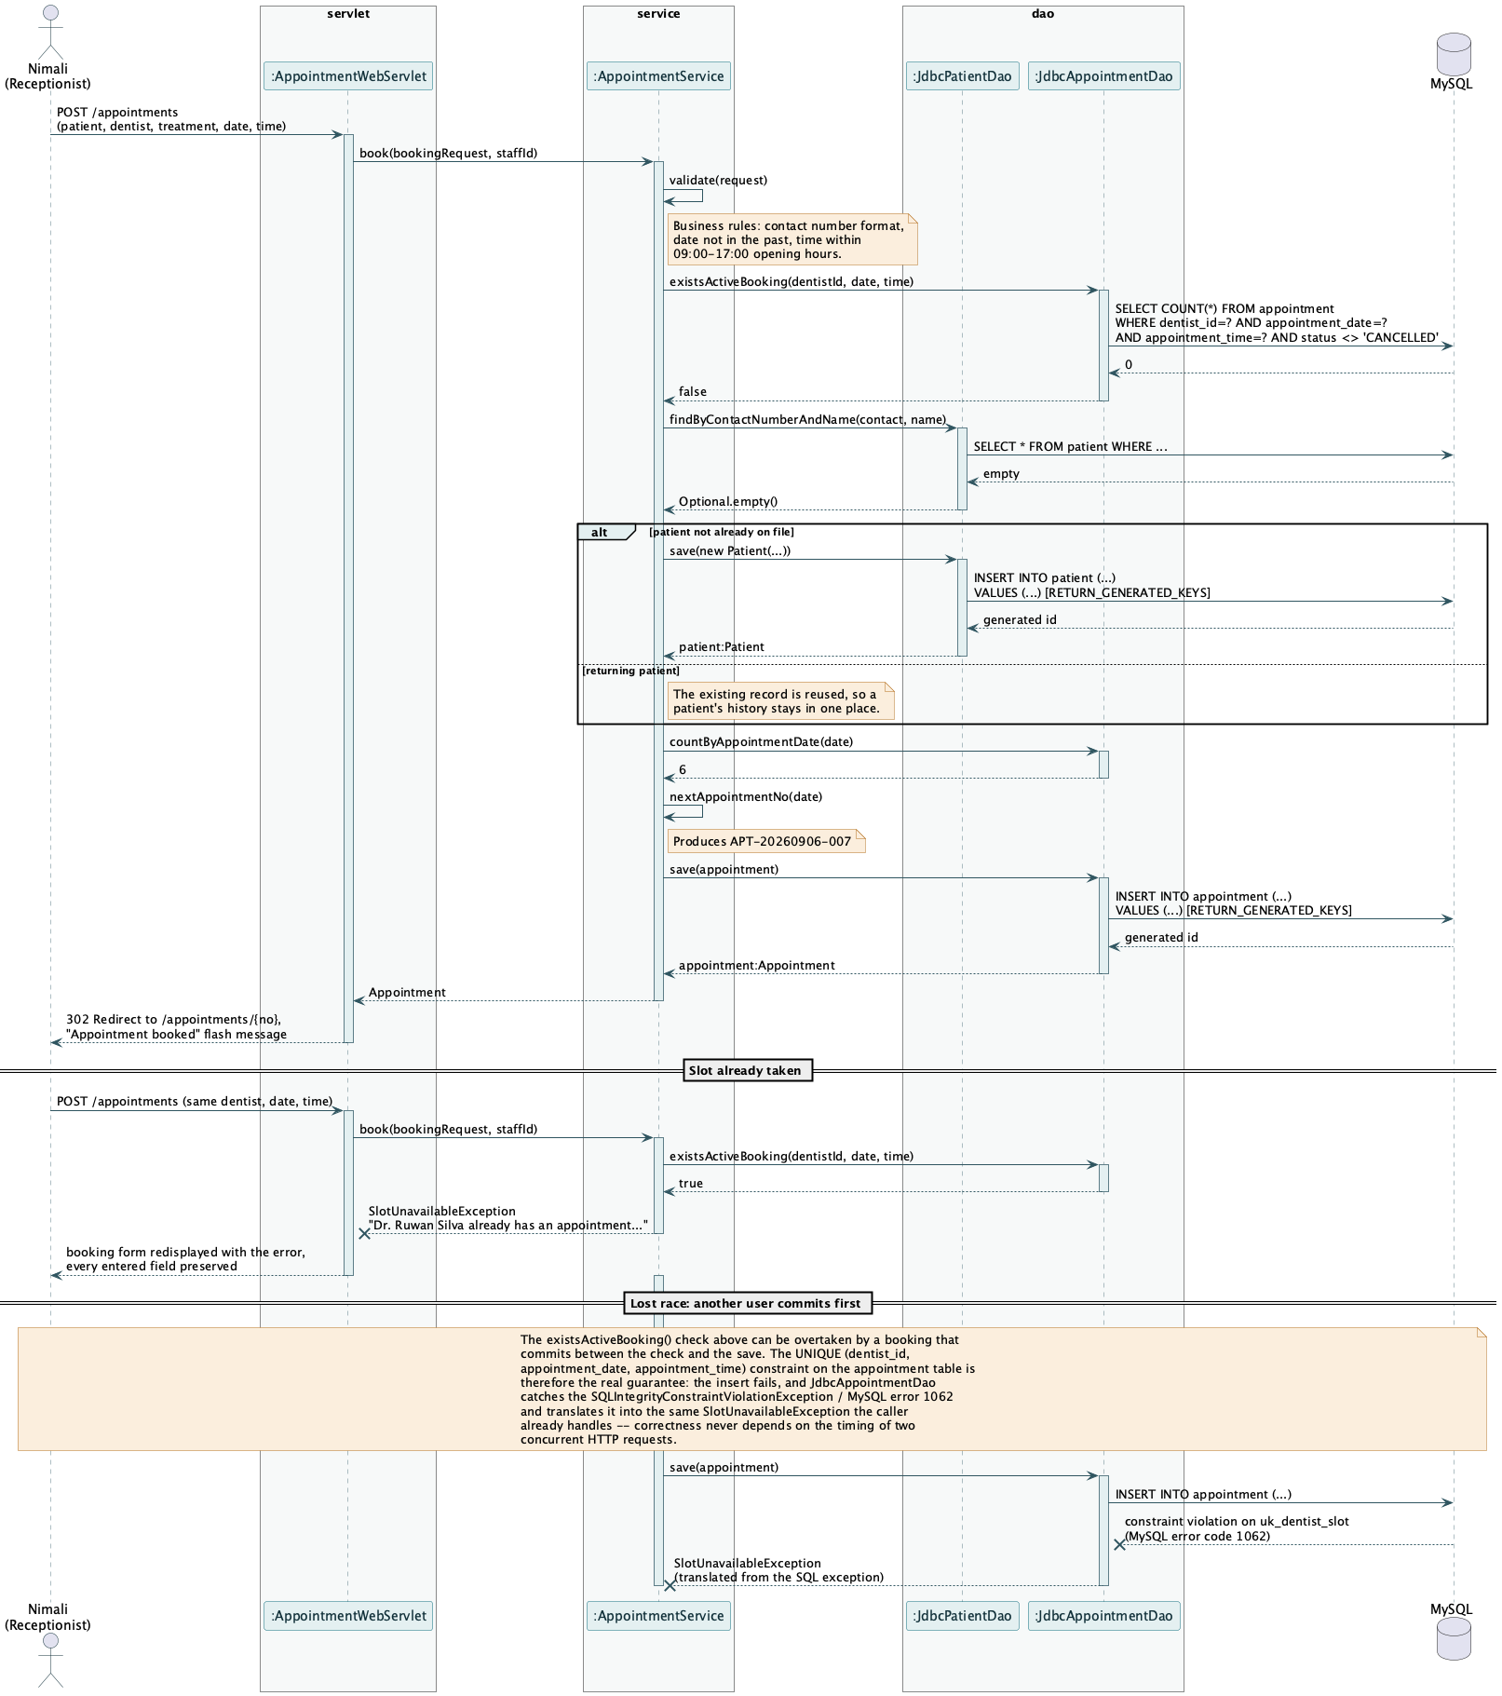
Figure 4: Sequence diagram — booking an appointment, including double-booking refusal and the concurrent-write race resolved by the database constraint

Scenario B: Staff Login Authentication
The login sequence shows where the session boundary falls. LoginServlet holds the HttpSession; AuthService verifies credentials and holds no session state of its own. A new session id is issued (getSession(true)) before the authenticated Staff object is stored in it, so a session id observed before login cannot be reused to ride the authenticated session. The diagram also shows the failure path: the same message is returned whether the username was unknown or the password was wrong, so the login form cannot be used to enumerate valid usernames.
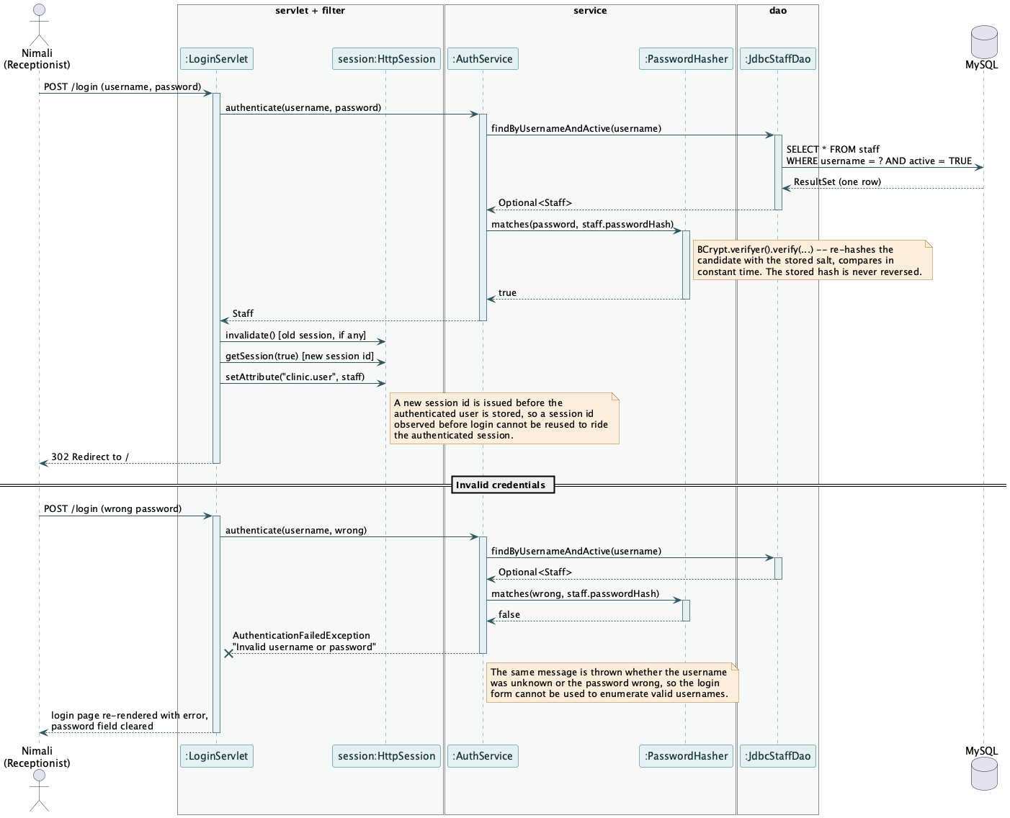
Figure 5: Sequence diagram — staff login, including the authentication failure path

Scenario C: Issuing a Bill
The senior submission this report's structure is modelled on used an administrator price-update scenario at this position; that feature does not exist here, and this scenario is used in its place because it demonstrates the two patterns — Strategy and Factory — doing real work. BillingService knows only that a bill totals a consultation fee plus a treatment charge; it does not know how any particular treatment is priced. BillingStrategyFactory resolves the correct BillingStrategy for the appointment's TreatmentCode, and that strategy computes the treatment charge. Repricing a treatment, or adding a new one, never touches BillingService.
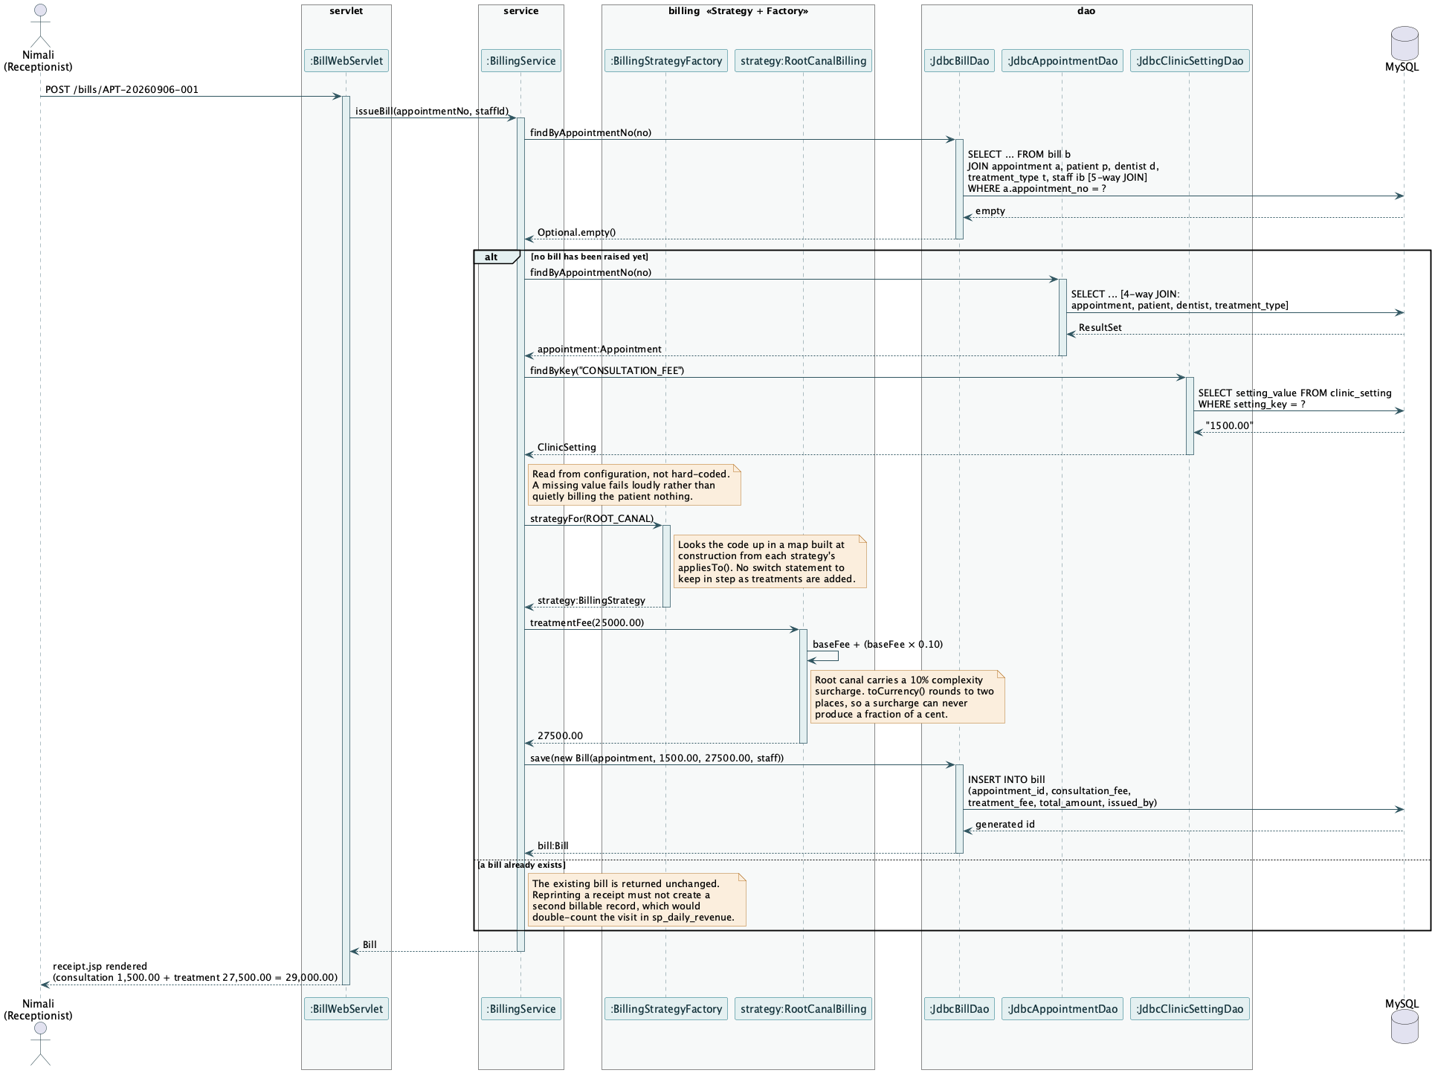
Figure 6: Sequence diagram — issuing a bill, showing Strategy and Factory resolving the treatment price

Comprehensive Codebase Evaluation

B.1 Distributed Web Services and Three-Tier Architecture
The brief requires a distributed application exposing web services. This is satisfied structurally: within the single deployed WAR, a family of servlets under /api/* returns JSON with no dependency on any JSP view, and is reachable by any HTTP client independently of a browser session — proven in the test plan by AppointmentApiServletTest, which drives the servlet directly with mocked request and response objects, and independently by curl against the running application.
$ curl http://localhost:8080/sunrise-dental/api/reference/dentists
[{"id":1,"name":"Dr. Ruwan Silva","specialization":"General Dentistry"}, ...]

$ curl -X POST http://localhost:8080/sunrise-dental/api/appointments \
-H 'Content-Type: application/json' -H 'X-Staff-Id: 1' \
-d '{"patientName":"Kamal Jayasuriya","address":"12 Galle Road",
"contactNumber":"0771234567","dentistId":1,"treatmentTypeId":1,
"appointmentDate":"2026-09-05","appointmentTime":"09:00"}'
{"appointmentNo":"APT-20260905-001","patientName":"Kamal Jayasuriya", ...}
Three tiers sit inside the one WAR. The servlet tier holds both the /api/* web services and the /* JSP-rendering servlets, guarded uniformly by AuthenticationFilter. The service tier — AppointmentService, AuthService, BillingService, ReportService — contains every business rule and depends only on DAO interfaces, never on a concrete JDBC class or a servlet type. The DAO tier talks to MySQL directly through JDBC. Nothing in the service or DAO tier imports jakarta.servlet.*, which is what makes those layers independently testable without a servlet container, discussed further in the Quality Assurance section.

The Web Service Endpoints (lk.icbt.clinic.servlet)
A single servlet can handle several related endpoint shapes because the Jakarta Servlet API, unlike a framework's annotated routing, has no built-in path-variable extraction: each servlet branches on HttpServletRequest.getPathInfo() by hand. JsonServlet, the abstract base every /api/* servlet extends, supplies that parsing once (pathParam), together with request-body deserialisation via Gson and a single method that maps a thrown domain exception to the correct HTTP status — SlotUnavailableException to 409, AppointmentNotFoundException to 404, InvalidBookingException to 400 — so that mapping is written once rather than once per servlet.
Method | Endpoint | Servlet | Purpose
POST | /api/auth/login | AuthApiServlet | Verify credentials, return the operator's identity. Stateless — no HttpSession is touched here.
POST | /api/appointments | AppointmentApiServlet | Book a visit — 201 Created, or 409 Conflict if the slot is taken
GET | /api/appointments?date= | AppointmentApiServlet | List a given day's bookings
GET | /api/appointments/{no} | AppointmentApiServlet | Retrieve an appointment by its reference
POST | /api/appointments/{no}/cancel | AppointmentApiServlet | Cancel a booking and release the slot
POST | /api/bills/{no} | BillApiServlet | Issue a bill, or return the existing one (assumption A7)
GET | /api/bills/{no} | BillApiServlet | Retrieve an issued receipt
GET | /api/reference/dentists | ReferenceApiServlet | Lookup data for the booking form
GET | /api/reference/treatments | ReferenceApiServlet | Lookup data with published fees
GET | /api/reports/daily-schedule?date= | ReportApiServlet | The day's appointments, ordered by time
GET | /api/reports/daily-revenue?date= | ReportApiServlet | Takings by treatment, via sp_daily_revenue
Table 2: The complete /api/* web service surface
The password hash never appears in any JSON response: StaffResponse, the record returned by both the login endpoint and every place a Staff is serialised, has no field for it, so no future change to Staff can accidentally expose it — the same structural guarantee a Data Transfer Object gives in a framework-based design, achieved here with a plain Java record.

B.2 Interactive User Interfaces and Pattern Integration
The presentation tier is JSP with JSTL and Jakarta EL, rendered by ViewServlet subclasses (DashboardServlet, AppointmentWebServlet, BillWebServlet, ReportWebServlet, HelpServlet) through a shared WEB-INF/tags/layout.tag so every page carries the same header, navigation and session-aware menu without repeating that markup. The interface is organised around one idea: the day rail, a ruled column of the clinic's opening hours that replaces the paper appointment book, built by DayRailBuilder and rendered as amber for a taken hour and plain for a free one.
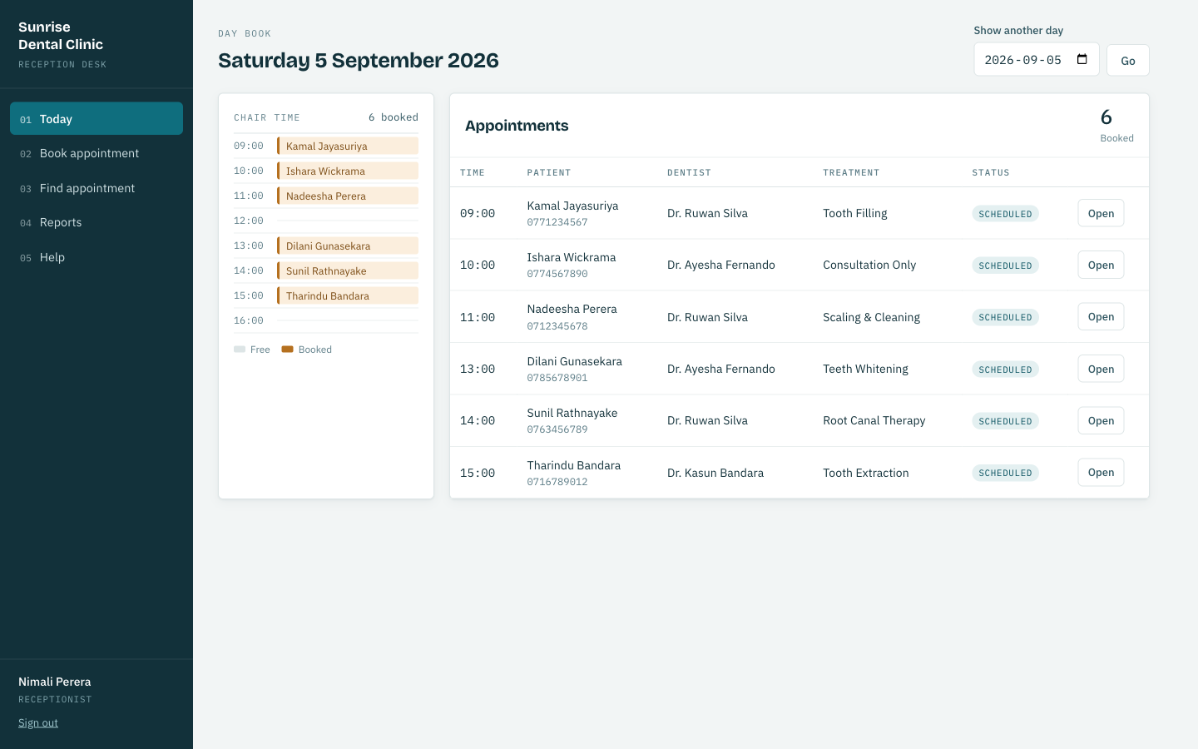
Figure 7: The day book. The rail on the left shows chair time; the table lists the day's appointments with status

Design patterns
Six patterns are applied. Each is described with the problem it solves and an honest account of what it cost, because a pattern applied without a problem to solve is decoration rather than design.
Strategy (billing package). The clinic prices treatments by different rules that change independently — a consultation carries no treatment charge, most treatments bill at their published fee, root canal therapy adds a 10% complexity surcharge. Each rule is a class implementing BillingStrategy (ConsultationOnlyBilling, StandardTreatmentBilling, RootCanalBilling). Adding a rule adds a class; changing one touches a single file rather than a growing conditional.
Factory (BillingStrategyFactory). Something must decide which strategy prices a given treatment. The factory asks each strategy which TreatmentCode values it claims through appliesTo(), and indexes the answer into a map at construction. Registration is a property of the strategy itself; the factory is never edited when a treatment is added, and two strategies claiming the same code fails fast at startup rather than silently picking one.
DAO / Repository (dao package). Seven interfaces isolate persistence from business logic. Because AppointmentService depends on AppointmentDao rather than JdbcAppointmentDao, it is exercised in AppointmentServiceTest against a Mockito mock with no database present at all — the pattern is what makes the business-rule tests fast enough to run on every change.
DTO (dto package). Records such as AppointmentResponse and StaffResponse decouple the JSON wire format from the domain model. The security property in B.1 — a hash that structurally cannot appear in a response — is this pattern's direct payoff.
Template Method (JsonServlet, ViewServlet). Every concrete servlet's doGet/doPost follows the same shape: parse the request, call a service, write a response or render a JSP. The abstract base classes supply that shape once — request parsing, error mapping, response writing — and each concrete servlet fills in only the one step that differs.
Manual Dependency Injection / Composition Root (AppContext, AppInitializer). Discussed fully in B.3. Named here because it is what makes every pattern above testable: each collaborator is received through a constructor parameter, never constructed with new inside the class that uses it, so a test can substitute a mock for any of them.

B.3 Advanced Database Architecture and Integrity Rules
Four features were deliberately placed in the database rather than the application, on the principle that a rule enforced by the schema holds for every client, whereas a rule enforced in application code holds only for requests that pass through that code — and this project has no framework to enforce that they always do.
Object | Type | Purpose
uk_dentist_slot | UNIQUE constraint on appointment(dentist_id, appointment_date, appointment_time) | Makes double booking impossible, including under concurrent requests — the guarantee exercised in Scenario A
uk_bill_appointment | UNIQUE constraint on bill(appointment_id) | Prevents a reprinted receipt from becoming a second billable row (assumption A7)
trg_appointment_status_audit | AFTER UPDATE trigger on appointment | Writes an audit row on every status change, whichever client made it
sp_daily_revenue | Stored procedure | Aggregates the day's takings by treatment inside the database, called via JdbcReportDao through a CallableStatement
Table 3: Advanced database features, all verified against MySQL 9.0
The stored procedure is used rather than the equivalent Java because aggregation belongs where the data lives: one summary result set crosses the network instead of every bill raised that day, and the definition of revenue stays in one place regardless of which client asks for it. The daily schedule report, by contrast, is a plain ordered SELECT executed from JdbcReportDao directly, because it gives the database nothing to do that the application could not do equally cheaply — the same reasoning the Spring version of this system used, applied here without an ORM to hide the SQL behind.

The Database Connection Layer (DbConnection.java)
With no framework-managed connection pool, DbConnection.get() opens one new java.sql.Connection per call via DriverManager, using a JDBC URL that must carry allowPublicKeyRetrieval=true — without it, MySQL 9's caching_sha2_password authentication plugin refuses to send credentials over a non-TLS connection at all, which surfaced during development as a 'Public Key Retrieval is not allowed' failure and was root-caused rather than worked around with a weaker authentication plugin. There is no pool deliberately: a hand-rolled one would be exactly the kind of infrastructure a framework like Spring normally supplies through HikariCP auto-configuration, and reproducing it would undercut the point of the exercise at this system's scale.
Credentials are resolved by DbConfig rather than hard-coded, in two steps: first an environment variable (DB_USERNAME, DB_PASSWORD), and if that is blank, a fallback to a local.properties file that is listed in .gitignore and never committed. This two-step resolution exists because environment variables set through an IDE's run configuration proved unreliable during development — DbConfig.get() was written, tested by reproducing the exact failure with both variables unset, and confirmed to start the application correctly from local.properties alone. No credential appears in source control under either path.
public static String get(String key) {
String fromEnv = System.getenv(key);
if (fromEnv != null && !fromEnv.isBlank()) return fromEnv;
return LOCAL.getProperty(key); // loaded from local.properties, gitignored
}

Database Setup Automation (versioned SQL scripts)
The senior submission referenced for this report's structure automates schema setup through a Java class, DatabaseInitializer.java, that runs DDL from the application at startup. This project takes a different, equally deliberate position: the schema is owned by four numbered SQL scripts in db/ (00-setup.sql, 01-schema.sql, 02-procedures.sql, 03-seed.sql), applied once by a human running the MySQL client, and never executed by the application itself.
Script | Responsibility
00-setup.sql | Creates the sunrise_dental database and a dedicated clinic_app MySQL account holding only the privileges the application needs — deliberately not root
01-schema.sql | Every table, primary key, foreign key, UNIQUE constraint and CHECK constraint, including uk_dentist_slot and uk_bill_appointment
02-procedures.sql | trg_appointment_status_audit, sp_daily_revenue, and fn_dentist_is_free — a read-only helper function used by reporting screens, kept explicitly separate from the UNIQUE constraint that is the actual booking guarantee
03-seed.sql | Reference data: dentists, treatment types and their published fees, and the two demonstration staff accounts
Table 4: The versioned database setup scripts, applied in order
The reasoning: an application that can run its own DDL is an application that could, through a bug or a misconfigured environment, run it against the wrong database, or run it every time it starts. Keeping schema changes as reviewable, numbered files under version control — applied deliberately, by a human, in a known order — was judged the safer default for a system whose central guarantee (uk_dentist_slot) is itself a schema-level object. This is the same trade-off the brief's advanced-database-features requirement is testing: whether the constraint that actually prevents the failure lives somewhere it cannot be silently skipped.

Sunrise Dental Clinic System — User Manual
These instructions are also provided inside the application itself, on a dedicated Help page, so that they are available at the reception desk rather than in a document nobody has to hand.

1. Introduction
This manual explains how reception staff and the clinic manager use the Sunrise Dental Clinic system day to day: signing in, booking and finding appointments, billing a patient, and — for the manager — viewing revenue reports.

2. System Prerequisites
- A modern web browser (Chrome, Firefox, Safari or Edge).
- Network access to the clinic's application server, running on Apache Tomcat 11.
- A staff username and password issued by the clinic administrator.

3. Logging In
- Open the application's address in a browser. You are taken to the sign-in page.
- Enter your username and password, then press Sign in.
- An incorrect username or password shows the same message either way, and the password field is cleared so it must be retyped.
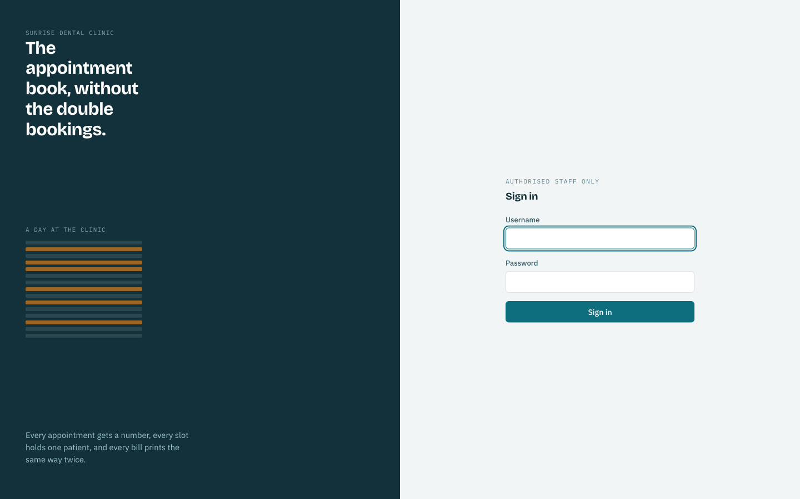
Figure 8: The sign-in screen. Only authorised staff may use the system

4. Navigating the Dashboard
After signing in you land on the dashboard, showing today's day rail and appointment list. The rail on the left is a ruled column of the clinic's opening hours: an amber row is a chair that is taken, a plain row is free. The menu at the top gives access to booking, finding an appointment, and — for a manager — reports.

5. Adding a New Patient
- Open Book appointment from the menu.
- Enter the patient's name, address and contact number.
- If this patient has visited before with the same name and contact number, the existing record is reused automatically and no duplicate is created.

6. Creating an Appointment
- Choose the dentist. Their day appears on the left of the form: amber rows are already taken.
- Choose a free time between 09:00 and 16:00. Choosing a taken slot and submitting is refused, with the dentist's name and the conflicting time named in the message.
- Choose the treatment type, then press Book appointment.
- Write the appointment reference shown on screen (for example APT-20260905-001) on the patient's card — it is how the booking is found again.
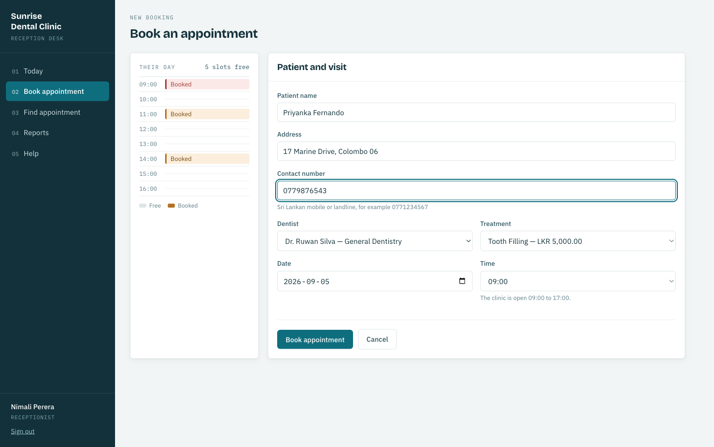
Figure 9: The booking form: the chosen dentist's day, with taken slots in amber
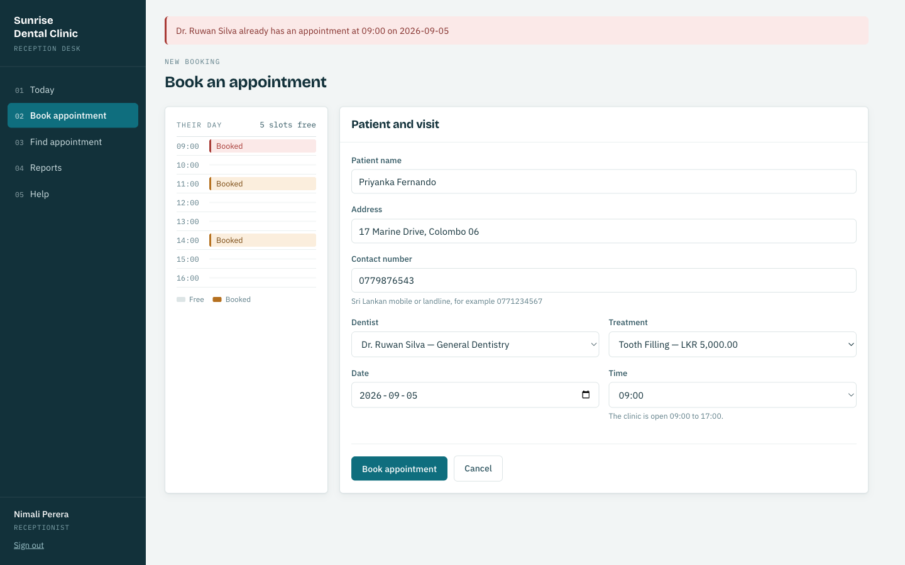
Figure 10: A double booking refused. The message names the dentist and time, and every entered field is preserved
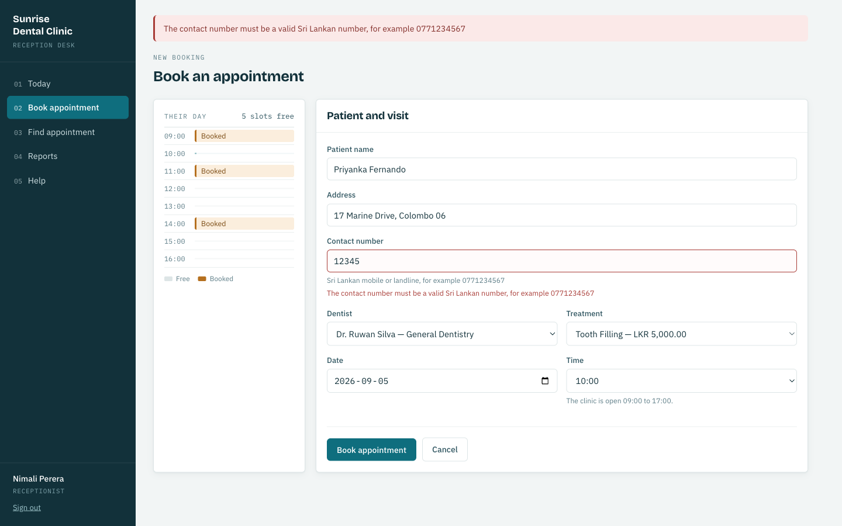
Figure 11: A validation failure. The message explains the expected format rather than only reporting failure

7. Calculating and Viewing Bills (Invoices)
- Open Find appointment and enter the reference number from the patient's card.
- The full record opens. Press Prepare bill to calculate the total — the consultation fee plus the treatment charge for the booked treatment.
- Press Print bill and hand the receipt to the patient. Pressing it twice is safe: the same bill is returned and the patient is never charged a second time.
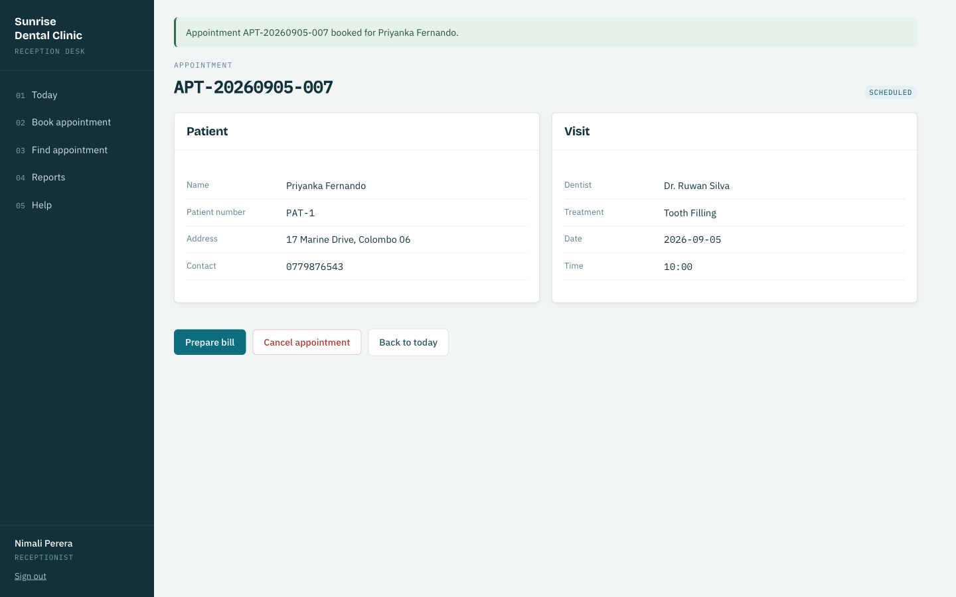
Figure 12: An appointment record, showing patient and visit details with the available actions
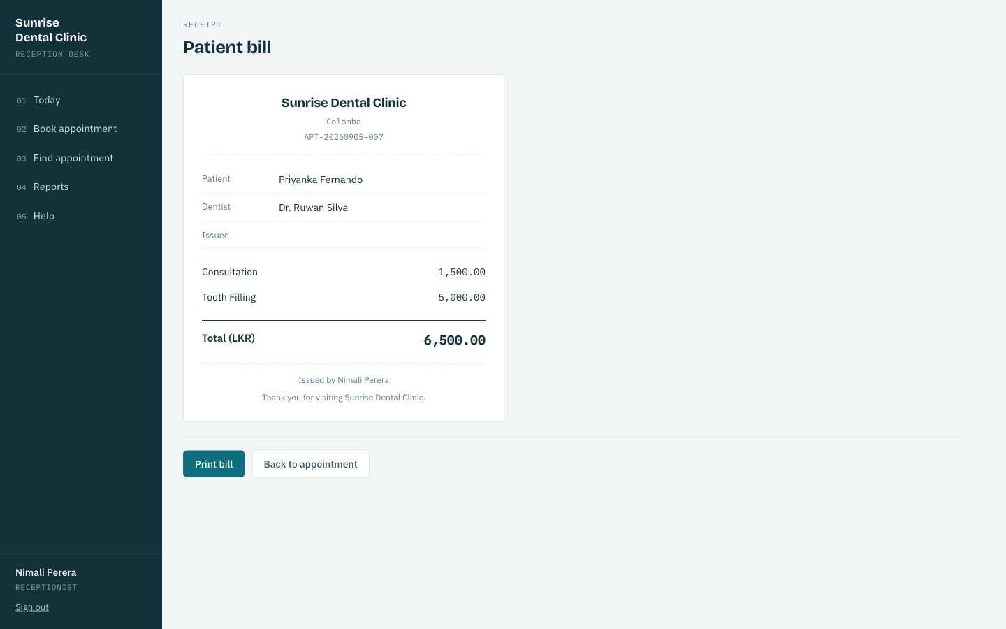
Figure 13: A patient receipt, showing the consultation fee and treatment charge separately
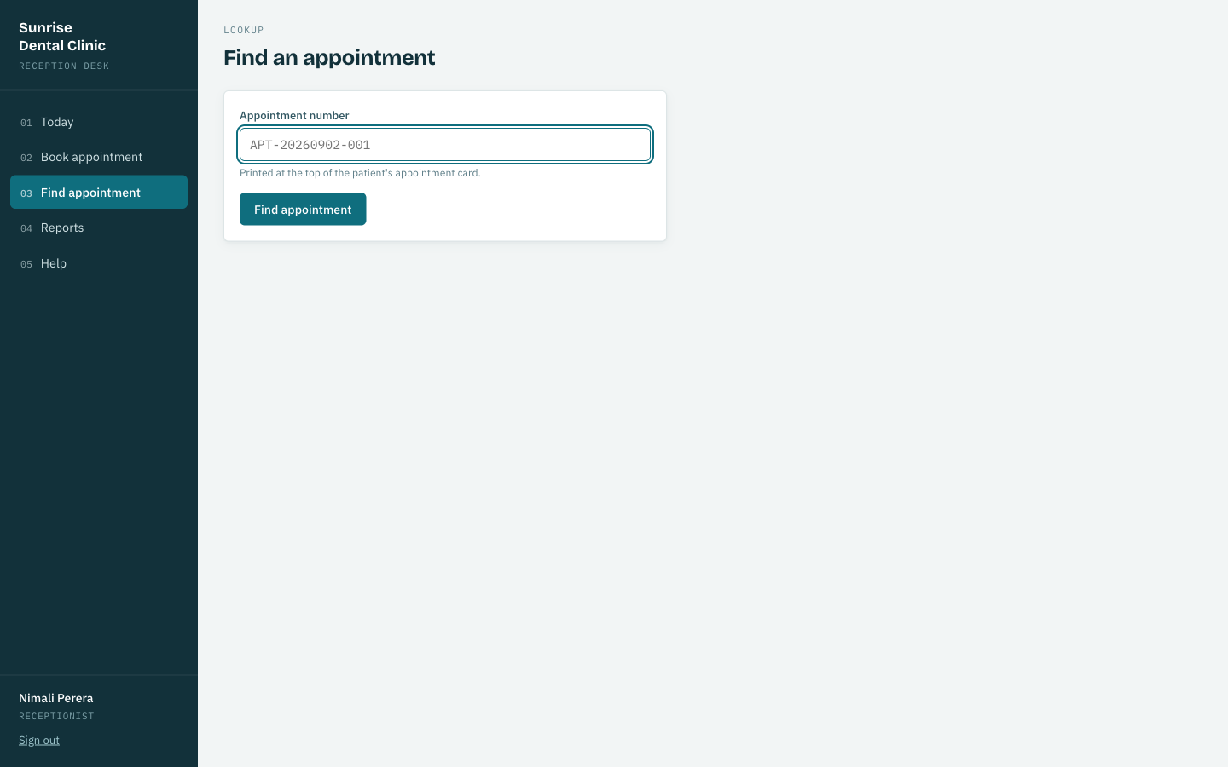
Figure 14: Searching for an appointment by its reference number

8. Viewing Reports (Manager Only)
A manager additionally sees Reports on the menu, showing the day's schedule and a revenue breakdown by treatment for a chosen date, generated by the sp_daily_revenue stored procedure.
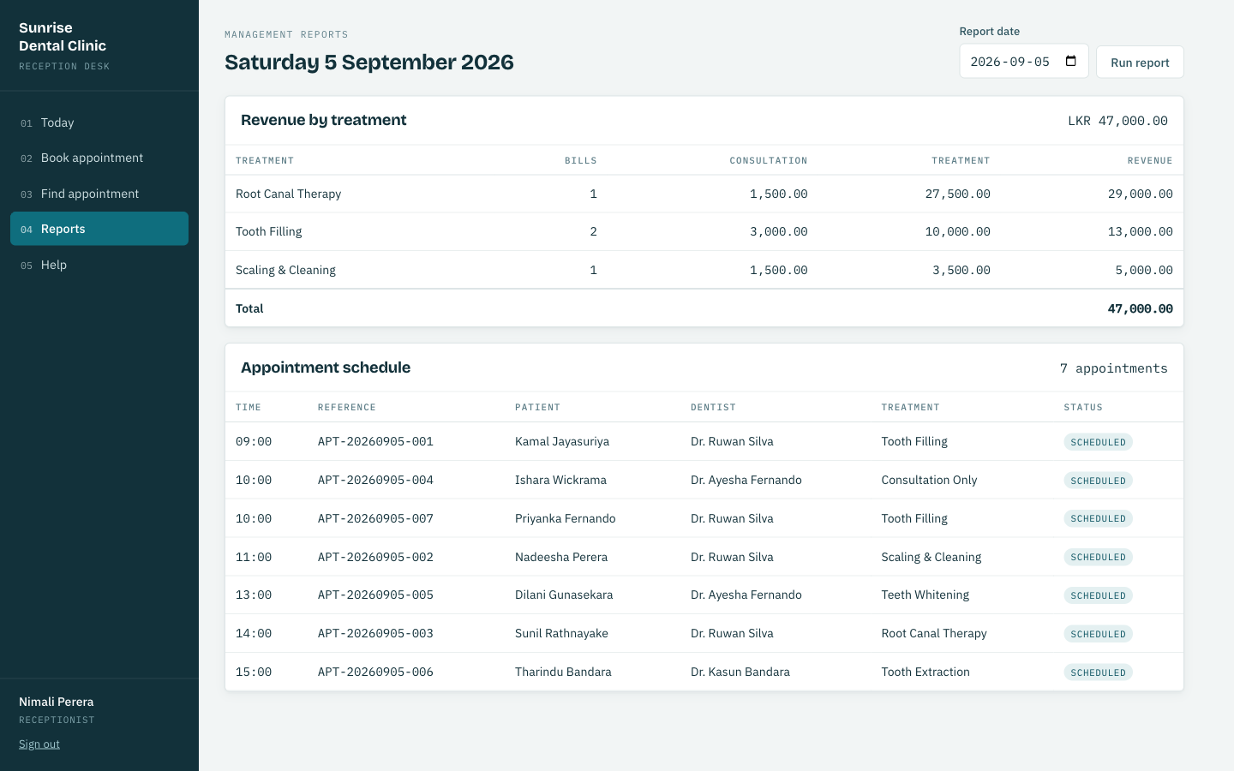
Figure 15: Management reports: the day's schedule and revenue by treatment

9. Exiting the System
- Press Log out in the menu when leaving the desk.
- The system also signs out automatically after thirty minutes of inactivity, so a workstation left unattended does not stay signed in indefinitely.
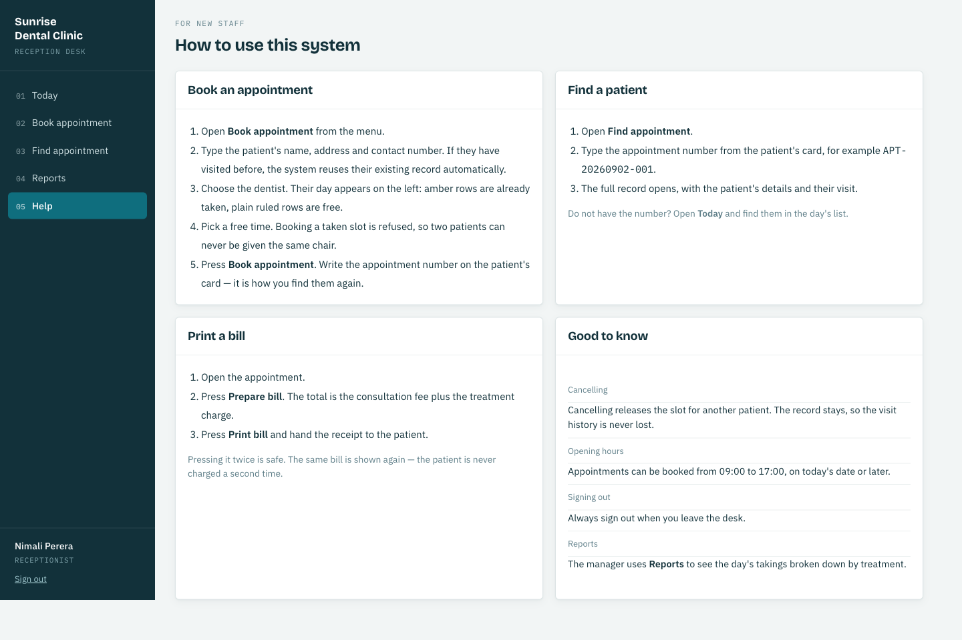
Figure 16: The in-application Help page, providing these instructions at the desk

Quality Assurance and Test-Driven Development (TDD)

C.1 Rationale for the Testing Approach and TDD
The testing strategy follows from the same analysis as the design: three of the clinic's four stated problems are correctness failures invisible at the moment they occur. Testing was aimed at pinning down the rules that prevent those failures — one dentist cannot hold two appointments in one slot, a reprinted bill cannot become a second charge, a surcharge cannot silently mis-round — and holding them still while the rest of the system changed around them.
Every business rule is tested at the service layer, reachable without a servlet container and without a database, so a failing test names the rule it protects rather than an HTTP status or a stack trace. The one HTTP-level test class, AppointmentApiServletTest, exists for a different question entirely: not whether the rule is correct, but whether the servlet reports it correctly — that a 409 really is a 409, not a 500 the caller has to guess at. Anything neither level could reach safely — the exact interleaving of two concurrent bookings — was pushed into the database instead, as the uk_dentist_slot constraint, on the grounds that a reliable concurrency test would require controlling two transactions' interleaving directly, which is disproportionate at this project's scale; Scenario A's sequence diagram documents the guarantee that the constraint, not a test, provides.

C.2 Test Automation Framework: JUnit 5 and Mockito
JUnit 5 provides the test runner and @DisplayName annotations, used throughout so that a failure report reads as a sentence stating the violated rule (for example, "refuses a second booking for the same dentist in the same slot") rather than a method name. Mockito supplies test doubles for every collaborator a class under test should not itself exercise — AppointmentDao when testing AppointmentService, AppointmentService when testing AppointmentApiServlet — and AssertJ's fluent assertions (assertThat(...).contains(...)) make the assertions themselves read close to the rule they check.
Because this project has no framework, there is no MockMvc or embedded test container available for the servlet layer. AppointmentApiServletTest instead constructs Mockito mocks of HttpServletRequest, HttpServletResponse and ServletContext directly, wires a ServletContext.getAttribute(AppInitializer.CONTEXT_KEY) call to return a test AppContext holding the mocked service, and calls doPost / doGet on the servlet directly — the same proof MockMvc gives a Spring controller (a request reaches the right code and produces the right status and body), built here from the same objects the servlet actually receives at runtime, with no simulated container in between.
Level | Tools | Executes against | Question answered
Unit | JUnit 5, Mockito, AssertJ | Mocked DAOs and collaborators | Is this business rule correct in isolation?
Servlet | JUnit 5, Mockito (HttpServletRequest/Response) | The real servlet class, mocked request/response | Does the servlet report the rule correctly over HTTP?
Database | MySQL 9.0, manual verification | The real schema, constraints, trigger and procedure | Do the schema-level guarantees actually hold?
System | Manual, in a browser | The full running application | Does the whole journey work for a receptionist?
Table 12: The four test levels and the distinct purpose of each

C.3 Derived Test Data
Test data was derived from the scenario and from assumptions A1–A7, chosen to sit exactly on the edges those rules define.
Field | Valid | Invalid | Expected outcome
Contact number | 0771234567 | 12345, empty | Rejected; message names the field
Appointment date | today, today + 1 | yesterday (fixed Clock: 2026-09-02) | "refuses to book a date that has already passed"
Appointment time | 09:00, 16:00 | 08:00, 20:00 | "refuses a time outside clinic opening hours"
Surcharge rounding | 333.33 × 1.10 | — | 366.66, scale exactly 2 — not 366.663
Zero base fee | 0.00 on root canal | — | 0.00; a percentage of nothing remains nothing
Same slot, twice | first booking | second booking, identical dentist/date/time | 409 Conflict at the servlet; SlotUnavailableException at the service
Table 13: Boundary and invalid test data, with expected outcomes
The 333.33 case is deliberate: it is the smallest input that makes the surcharge calculation produce a fraction of a cent, which is not a payable amount. It forces the rounding decision to be made explicitly rather than inherited from whatever BigDecimal happens to do by default, and it is the same edge case the domain model's composition relationship (Appointment–Bill, Section 2) exists to protect: a Bill that cannot be constructed with an unrepresentable amount.

C.4 Requirements Traceability Matrix (RTM)
Every functional requirement in the brief is mapped to at least one test that holds it.
Req. | Requirement | Verifying test | Level
1.1 | Username and password required to sign in | authenticates a member of staff with the correct password | Unit
1.2 | No username enumeration on failure | gives the same message whether the user or the password was wrong | Unit
2.1 | Every appointment carries a unique reference | books an appointment and issues it a unique reference | Unit
2.2 | References are dated and sequential | appointment references are unique per day and carry the date | Unit
2.3 | No double booking | refuses a second booking for the same dentist in the same slot | Unit
2.4 | Double booking reported correctly over HTTP | booking the same dentist twice in one slot returns 409 Conflict | Servlet
2.5 | Double booking impossible under concurrency | uk_dentist_slot UNIQUE constraint | Database
2.6 | No duplicate patient records | reuses the existing patient record instead of registering a duplicate | Unit
2.7 | No booking in the past | refuses to book a date that has already passed | Unit
2.8 | Booking confined to opening hours | refuses a time outside clinic opening hours | Unit
2.9 | Contact number validated | rejects a contact number that is not a valid Sri Lankan mobile | Unit
3.1 | Search by appointment reference | GET /api/appointments/{no} returns the booking | Servlet
3.2 | Unknown reference reported clearly | looking up an unknown appointment number fails clearly | Unit
4.1 | Bill totals consultation plus treatment fee | a bill is the consultation fee plus the treatment fee | Unit
4.2 | Surcharge applied correctly | the root canal surcharge reaches the bill | Unit
4.3 | Currency rounded to two places | fees are rounded to two decimal places for currency | Unit
4.4 | Every treatment priceable | every treatment the clinic offers can be priced | Unit
4.5 | Reprint never double-bills | reprinting a receipt returns the original bill rather than issuing a second | Unit
4.6 | Misconfiguration fails loudly | a missing consultation fee setting fails loudly rather than billing zero | Unit
5.1 | Day rail correctly reflects booked/free/cancelled slots | marks a booked hour as taken and names the patient / a cancelled appointment leaves its slot free | Unit
5.2 | Manager-only revenue report | sp_daily_revenue callable and returns a well-formed result set | Database
6.1 | Safe exit | session timeout (30 min) and AuthenticationFilter default-deny route guard | System
Table 14: Requirements traceability matrix, mapping brief requirements to the tests that hold them

C.5 Exhaustive Test Plan (36 Detailed Test Cases)
The full suite comprises 36 automated tests across seven classes. Every test is listed below, grouped by class, with the precondition shared by that class's tests, the steps each test performs, and the expected result — restated from each test's own @DisplayName so the table can be read as a specification independent of the source code.

AuthServiceTest (Unit)
Precondition: A Staff record exists with username "reception" and a BCrypt hash of "Recept@123"; StaffDao and PasswordHasher are mocked.
ID | Test | Steps | Expected result
TC-01 | authenticates a member of staff with the correct password | Call authenticate("reception","Recept@123") | Returns the matching Staff
TC-02 | rejects a wrong password | Call authenticate("reception","wrong") | Throws AuthenticationFailedException
TC-03 | rejects an unknown username | Call authenticate("nobody","x") | Throws AuthenticationFailedException
TC-04 | gives the same message whether the user or the password was wrong | Compare the exception message for an unknown user vs. a known user with a wrong password | Both messages are identical
TC-05 | a blank password is rejected without consulting the database | Call authenticate("reception","") | Throws AuthenticationFailedException without querying StaffDao
Table 5: Detailed test cases — AuthServiceTest

DayRailBuilderTest (Unit)
Precondition: A list of Appointment objects for one dentist on one date is prepared, covering booked, cancelled and completed statuses.
ID | Test | Steps | Expected result
TC-06 | covers every opening hour from 09:00 to 16:00 | Call DayRailBuilder.build() with no appointments | Returns exactly 8 DaySlot entries, 09:00 through 16:00
TC-07 | marks a booked hour as taken and names the patient | Build the rail with one CONFIRMED appointment at 10:00 | The 10:00 slot reports isTaken() true and the correct patient name
TC-08 | a cancelled appointment leaves its slot free | Build the rail with a CANCELLED appointment at 11:00 | The 11:00 slot reports isTaken() false
TC-09 | a completed appointment still occupies its slot | Build the rail with a COMPLETED appointment at 12:00 | The 12:00 slot reports isTaken() true
Table 6: Detailed test cases — DayRailBuilderTest

AppointmentApiServletTest (Servlet (integration-equivalent))
Precondition: AppointmentService is mocked; HttpServletRequest, HttpServletResponse and ServletContext are Mockito mocks wired to a test AppContext.
ID | Test | Steps | Expected result
TC-10 | POST /api/appointments books a visit and returns 201 with its reference | POST a valid JSON booking body to the servlet's doPost | resp.setStatus(201); body contains the generated appointmentNo
TC-11 | booking the same dentist twice in one slot returns 409 Conflict | doPost when the mocked service throws SlotUnavailableException | resp.setStatus(409); body's "error" is "Slot Unavailable"
TC-12 | GET /api/appointments/{no} returns the booking | GET with pathInfo "/APT-20260902-007" | resp.setStatus(200); body contains the treatment name
Table 7: Detailed test cases — AppointmentApiServletTest

BillingServiceTest (Unit)
Precondition: An Appointment fixture, a ClinicSettingDao stub for the consultation fee, and a BillingStrategyFactory resolving real strategies are wired to BillingService with BillDao mocked.
ID | Test | Steps | Expected result
TC-13 | a bill is the consultation fee plus the treatment fee | issueBill() for a standard-treatment appointment | total = consultation fee + published treatment fee
TC-14 | the root canal surcharge reaches the bill | issueBill() for a root-canal appointment | total includes the 10% complexity surcharge
TC-15 | a consultation-only visit is billed the consultation fee alone | issueBill() for a consultation-only appointment | treatment charge is 0.00; total = consultation fee
TC-16 | reprinting a receipt returns the original bill rather than issuing a second | Call issueBill() twice for the same appointment | Second call returns the same Bill; BillDao.save() invoked only once
TC-17 | billing an unknown appointment fails clearly | issueBill() for a reference not returned by AppointmentDao | Throws AppointmentNotFoundException
TC-18 | a missing consultation fee setting fails loudly rather than billing zero | ClinicSettingDao returns no value for the consultation-fee key | Throws an explicit failure rather than billing 0.00
Table 8: Detailed test cases — BillingServiceTest

AppointmentServiceTest (Unit)
Precondition: AppointmentDao, PatientDao and a fixed Clock (2026-09-02) are mocked or stubbed and injected into AppointmentService.
ID | Test | Steps | Expected result
TC-19 | books an appointment and issues it a unique reference | book() a valid BookingRequest | Returns an Appointment with a non-null appointmentNo
TC-20 | refuses a second booking for the same dentist in the same slot | book() the same dentist/date/time twice, mock reporting the slot occupied | Second call throws SlotUnavailableException naming dentist, date and time
TC-21 | refuses to book a date that has already passed | book() with appointmentDate before the fixed clock's today | Throws InvalidBookingException
TC-22 | refuses a time outside clinic opening hours | book() with appointmentTime 20:00 | Throws InvalidBookingException
TC-23 | reuses the existing patient record instead of registering a duplicate | book() with a name and contact number matching an existing Patient | PatientDao.save() is not called a second time; the existing Patient is reused
TC-24 | rejects a contact number that is not a valid Sri Lankan mobile | book() with contactNumber "12345" | Throws InvalidBookingException naming the contact-number field
TC-25 | appointment references are unique per day and carry the date | book() two appointments on the same date | References share the date component and increment sequentially, e.g. APT-20260902-001 / -002
TC-26 | looking up an unknown appointment number fails clearly | findByAppointmentNo() with a reference AppointmentDao does not know | Throws AppointmentNotFoundException
Table 9: Detailed test cases — AppointmentServiceTest

BillingStrategyFactoryTest (Unit)
Precondition: The factory is constructed with the three real strategy implementations.
ID | Test | Steps | Expected result
TC-27 | resolves the strategy that declares the requested treatment | strategyFor(ROOT_CANAL) | Returns the RootCanalBilling instance
TC-28 | every treatment the clinic offers can be priced | Call strategyFor() for every value of TreatmentCode | No call throws; every code resolves
TC-29 | rejects two strategies claiming the same treatment | Construct a factory from two strategies both claiming FILLING | Throws at construction time
Table 10: Detailed test cases — BillingStrategyFactoryTest

BillingStrategyTest (Unit)
Precondition: Each concrete strategy (ConsultationOnlyBilling, StandardTreatmentBilling, RootCanalBilling) is tested in isolation with a BigDecimal base fee.
ID | Test | Steps | Expected result
TC-30 | a consultation-only visit is charged no treatment fee | ConsultationOnlyBilling.treatmentFee(5000.00) | Returns 0.00
TC-31 | a standard treatment is charged its published base fee | StandardTreatmentBilling.treatmentFee(5000.00) | Returns 5000.00 unchanged
TC-32 | root canal therapy adds a 10% complexity surcharge | RootCanalBilling.treatmentFee(25000.00) | Returns 27500.00 (10% surcharge)
TC-33 | fees are rounded to two decimal places for currency | RootCanalBilling.treatmentFee(333.33) | Returns 366.66, scale exactly 2 — not 366.663
TC-34 | a zero base fee stays zero rather than becoming a surcharge | RootCanalBilling.treatmentFee(0.00) | Returns 0.00
TC-35 | each strategy declares which treatments it prices | Call appliesTo() on each strategy | Each returns a non-empty, non-overlapping set of TreatmentCode
TC-36 | the three strategies together cover every treatment the clinic offers | Union the three strategies' appliesTo() sets | Equals the full set of TreatmentCode values
Table 11: Detailed test cases — BillingStrategyTest

C.6 Evaluation of Overall Success and Lessons Learned
All 36 tests pass, in well under three seconds, which is what makes the suite something to run constantly rather than occasionally.
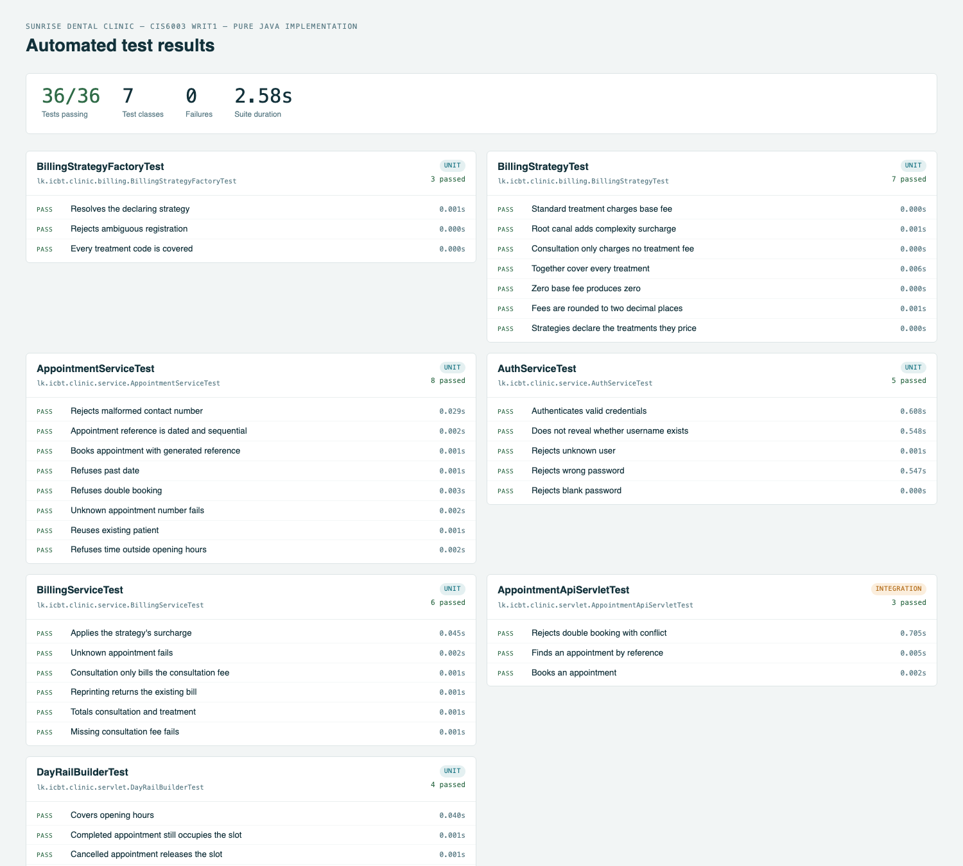
Figure 17: Automated test results — 36 of 36 passing, grouped by class, generated from the Maven Surefire reports
What the suite achieves. Every rule that prevents one of the clinic's four stated problems has a named test stating the rule in business language. Because AppointmentService and BillingService depend only on DAO interfaces, the entire business-rule suite runs with no database and no servlet container, which is what keeps it fast enough to run on every change rather than being reserved for a pipeline.
What it does not reach. The suite tests one servlet, AppointmentApiServletTest, as a demonstration that the mocked-request technique proves the same contract MockMvc would in a Spring project. It was not extended to every servlet, on the judgement that the servlets sharing JsonServlet's base behaviour (error mapping, JSON writing) would largely re-test that shared code rather than new logic; the remaining risk in those servlets is thin path-parsing logic, exercised instead by manual and curl-based system testing, captured in the endpoint evidence in Section B.1. There is also no automated test of the concurrent double-booking race itself — as in Section C.1, the guarantee is provided by the database constraint and argued through the sequence diagram, not exercised by an interleaved-transaction test.
Honesty about the development order. This rewrite's git history is organised by architectural layer — domain, then DAO, then billing, then service, then servlets, then JSP, then tests — rather than as a literal red-then-green commit-by-commit record. That is a genuine difference from strict test-driven development, and it is recorded here rather than implied otherwise: the business rules and their tests were designed together from an existing, already-tested specification (this system's own earlier Spring implementation, built test-first, and the Spring project's report documents that red/green cycle directly), and this rewrite's task was to reproduce the same guarantees without a framework, not to rediscover them. The lesson carried forward is the same one that motivated writing tests at the service layer in the first place: a rule stated as a named test survives a rewrite of everything around it, including the removal of an entire application framework, provided the interface the test depends on — here, the DAO interfaces — is kept stable across the rewrite.

Version Control, CI/CD and Deployment

D.1 Repository and commit practice
The project is held in a local Git repository, organised into ten commits following the Conventional Commits convention (feat, test, chore prefixes), each leaving the build in a working state and scoped to one architectural layer: scaffold, domain, dao, billing, service, web (servlets and filter), view (JSP), dev (the embedded-Tomcat entry point), test, and finally the CI workflow itself.
Commit | Scope
afc7be9 | chore: scaffold pure Java WAR project
c3ddb67 | feat(domain): plain Java domain model and exception types
83f58bf | feat(dao): hand-written JDBC persistence layer
aee8726 | feat(billing): Strategy and Factory pricing patterns
808eb36 | feat(service): business logic and manual dependency wiring
2d4156c | feat(web): REST web services and JSP-rendering servlets
1542b94 | feat(view): JSP presentation tier
84e7d3b | feat(dev): embedded-Tomcat entry point for running from an IDE
373f05c | test: unit and servlet-level test suite
f68076c | chore(ci): add GitHub Actions build and test pipeline
Table 15: Commit history, in order
Six annotated tags mark version milestones, v0.1.0 through v1.1.0, each with a descriptive message recording what that milestone added — the scaffold, the domain and persistence layer, the web services, the presentation tier, the release, and the CI pipeline.

D.2 Continuous integration pipeline
A GitHub Actions workflow (.github/workflows/ci.yml) runs on every push and pull request: it installs Java 21, runs the full test suite with ./mvnw -B test, packages the WAR with ./mvnw -B package, and publishes both the Surefire test reports and the packaged WAR as build artifacts. No database service container is required, because all 36 tests in the suite execute against Mockito mocks rather than a real MySQL connection — a direct consequence of the DAO-interface pattern discussed in Section B.2, which is what keeps the pipeline simple and fast for this project.
- name: Build and run the test suite
run: ./mvnw -B test
- name: Package the WAR
run: ./mvnw -B package -DskipTests
Evaluation. The pipeline catches regressions in every business rule and every reported HTTP status the moment a change is pushed. It does not verify the database layer at all — the schema scripts, the constraint, the trigger and the stored procedure are applied and tested only by hand against a local MySQL instance, unlike the Spring implementation of this same system, whose pipeline runs a second job against a real MySQL service container specifically to validate those objects. Adding an equivalent job here, applying db/01-schema.sql and db/02-procedures.sql to a MySQL service container and then exercising uk_dentist_slot and sp_daily_revenue directly, is the clearest next step for this pipeline and is not yet done.

Critical Evaluation and Conclusion
The delivered system addresses each of the four problems the scenario identifies, without relying on an application framework to do so. Double booking is prevented at three independent levels, of which the database constraint is the only one sufficient on its own. Lost records are addressed by matching returning patients on name and contact number. Waiting times are addressed by the day rail, which makes the shape of a dentist's day readable at a glance. Billing errors are addressed by deriving every total from stored fees through a tested Strategy, and by ensuring a reprinted receipt returns the original bill rather than creating a second one.

What the approach achieved
Removing the framework did not remove the responsibilities a framework normally carries — it relocated them into this project's own source, where they can be read, tested and evaluated directly. AppContext is a visible, sixty-line answer to a question Spring usually answers invisibly. The Repository and DTO patterns, which in the Spring implementation of this system existed partly because that was idiomatic Spring, here exist because nothing else would make the service layer testable without a database, or keep a password hash out of a JSON response.

Limitations and what would be done differently
- The CI pipeline does not verify the database objects — the constraint, the trigger and the stored procedure are checked by hand, not on every push.
- Only one servlet has an automated HTTP-level test. The remaining servlets share JsonServlet's error-mapping and response-writing code, which is exercised indirectly, but their own path-parsing logic is verified only manually.
- There is no automated concurrency test for the double-booking race; the guarantee is argued from the schema constraint rather than exercised by a test that interleaves two transactions.
- Connection-per-request, with no pool, is appropriate at this project's scale but would not survive meaningfully higher load without revisiting DbConnection.

Conclusion
The exercise reinforced a principle that recurs throughout the work: a guarantee should be placed at the level where it actually holds, and removing a framework does not change where that level is — it only removes the framework's help in getting there. Validation in the JSP form improves usability but guarantees nothing; validation in the service layer produces a clear message but can be overtaken by concurrency; only the constraint in the schema is sufficient. Recognising which level a given rule belongs to, and then building — by hand, with no framework to default to — exactly the amount of infrastructure that level requires, was the central discipline of this rewrite.

References
Bloch, J. (2018) Effective Java. 3rd edn. Boston: Addison-Wesley.
Fowler, M. (2002) Patterns of Enterprise Application Architecture. Boston: Addison-Wesley.
Gamma, E., Helm, R., Johnson, R. and Vlissides, J. (1994) Design Patterns: Elements of Reusable Object-Oriented Software. Reading, MA: Addison-Wesley.
Martin, R.C. (2008) Clean Code: A Handbook of Agile Software Craftsmanship. Upper Saddle River, NJ: Prentice Hall.
Meszaros, G. (2007) xUnit Test Patterns: Refactoring Test Code. Boston: Addison-Wesley.
Oracle (2024) MySQL 9.0 Reference Manual. Available at: https://dev.mysql.com/doc/refman/9.0/en/ (Accessed: 5 September 2026).
Oracle (2024) Jakarta Servlet 6.1 Specification. Available at: https://jakarta.ee/specifications/servlet/6.1/ (Accessed: 5 September 2026).
Oracle (2024) Jakarta Server Pages 3.1 Specification. Available at: https://jakarta.ee/specifications/pages/3.1/ (Accessed: 5 September 2026).
The Apache Software Foundation (2025) Apache Tomcat 11 Documentation. Available at: https://tomcat.apache.org/tomcat-11.0-doc/ (Accessed: 5 September 2026).

Appendix A — Additional Interface Evidence
Evidence not already placed inline with the section it supports.

Appendix B — Running the System
With MySQL 9.0 installed and running locally, apply the schema once:
mysql -u root -p < db/00-setup.sql
mysql -u root -p < db/01-schema.sql
mysql -u root -p < db/02-procedures.sql
mysql -u root -p < db/03-seed.sql
Then either run from an IDE using the embedded-Tomcat entry point, or build and deploy the WAR to a standalone Tomcat 11:
./mvnw -DskipTests package
cp target/sunrise-dental.war $CATALINA_HOME/webapps/
Sign in as reception / Recept@123 for the receptionist role, or manager / Manager@123 for the manager role. Credentials are supplied via the DB_USERNAME and DB_PASSWORD environment variables, or via a local.properties file (never committed) if those are not set.
The full test suite is executed with:
./mvnw test # 36 tests, no database required

